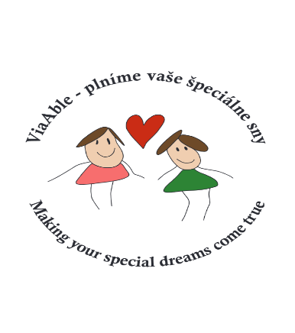
Must-bring checklist:
One luggage per person: small backpack or handbag, dimensions 40×30×20 cm, and carry-on luggage per person: travel suitcase up to 10 kg, dimensions 55×40×20 cm
- Liquid cosmetics, liquid toiletries, liquids allowed only up to 100 ml
- Sunscreen up to 100 ml
- Head covering (hat/cap)
- 2x swimsuits, towel
- Sturdy footwear – sneakers, sandals (not flip-flops)
- Valid passport with official notation – Severely Disabled / Handicapped
- Participants with ASD – autism spectrum disorder card
- Disability Card
- Medical certificate from a general practitioner / paediatric psychiatrist confirming fitness to travel and non-infectious status
- List of all medications, including the patient information leaflet enclosed in the medicine packaging and dosage instructions
- Health insurance card
- Wheelchairs, strollers, suitcases, and other aids – please label with full name
- Copies of passport, health insurance card, disability card, and for participants with ASD, the ASD card – send to JLviaable@gmail.com along with other completed forms

